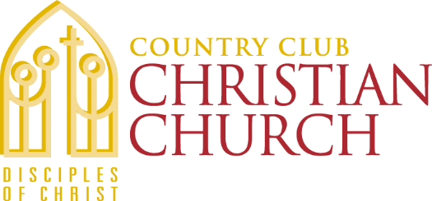
Country Club Christian Church
6101 Ward Parkway
Kansas City, MO 64113
(816) 333-4917

Grants & Special Offerings
Funding Guidelines & Application 2020-2021

IV. PROPOSAL NARRATIVE
Please summarize in a maximum of three pages the following information regarding the organizations grant request.
Background – Describe the work of the organization, addressing each of the following:
- Explain why the organization is requesting funding, what outcomes you hope to achieve and how the funds will be spent if a grant is made.
- Describe the work of your agency including history, mission statement, the need or problem the organization works to address, population served, and geographical reach.
- Current programs and accomplishments.
- Other organizations within the same geographical location providing similar service or programs.

Funding Request – Describe the program, service or project for which the organization is seeking funding, addressing the following:
- If requesting for general operating support, describe how this grant funding would be used.
- If requesting for a specific program, service or project, please explain the objective of the project including the following details.
- A statement of its primary purpose and the need or problem that the organization is seeking to address.
- The population that is served.
- Strategies used to achieve positive results
- Anticipated length of project
- How the program, service or project contributes to the organization’s mission statement.
- Please explain how the organization will measure the effectiveness of the activities. Describe the criteria for a successful program, service or project and the results the organization expects to have achieved by the end of the funding period.

